Java – Topic 27
(Graphics in Applets)

TASK

QUESTION
Recreate the following in an applet (details below).

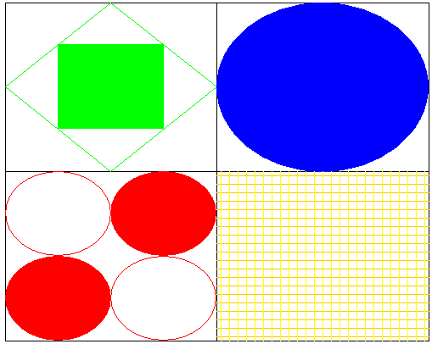

Details:

- To set the colour to red, you use:

g2D.setColor(Color.red);

To set the colour to green, you use:

g2D.setColor(Color.green);
- The only value regarding coordinates that you need is the size of the grid at the bottom. Lines are 10 pixels apart.

For maximum marks, your applet has to work for any size. In other words, if I size it differently in the html code, it should all resize.

